



**编者按：**

为了让我校师生快速了解国内外学术前沿、经典及热点，图书馆学科服务团队特开辟此栏目，利用WOS/ESI/Incites、Scopus/SciVal等权威数据库和分析工具筛选研究前沿，或跟踪重要学术网站获取最新学术动态，分专题进行编译报道。广大师生若有其他关注的领域和专题，也可向我们推荐。

本期推荐报道2022年5月Nature、Science期刊上物理学领域的部分最新论文。

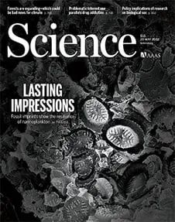

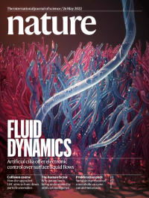

*CONTACT US*



联系电话：025-52090336-801

办公地址：李文正图书馆B401室

本期审核：陆 美

**2022-第十六期-物理学**



**5月Science论文**

[1]**All topological bands of all nonmagnetic stoichiometric materials**

**非磁性化学计量材料的拓扑带**

**出版信息**：Science, 20 MAY 2022, VOL 376, ISSUE 6595

**作者：**MAIA G. VERGNIORY, BENJAMIN J. WIEDER, LUIS ELCOROSTUART, S. P. PARKIN, NICOLAS REGNAULT, etc.

**第一作者单位：**Donostia International Physics Center, 20018 Donostia–San Sebastian, Spain. IKERBASQUE, Basque Foundation for Science, Bilbao, Spain. Max Planck Institute for Chemical Physics of Solids, 01187 Dresden, Germany.

**全文链接：**<https://www.science.org/doi/10.1126/science.abg9094>

**Abstract：**Topologically nontrivial materials were once thought to be the exception rather than the rule. More recently, high-throughput computations have shown that many more materials are topological than was initially thought. Vergniory et al. expanded this approach to include all processable entries in the Inorganic Crystal Structure Database and studied the materials’ band structure both at and away from Fermi energy. The researchers found that almost 88% of these materials had at least one topological band.

**摘要翻译：**拓扑上的非平凡材料曾经被认为是例外而非规律。最近，高通量计算表明，更多的材料比最初认为的具有拓扑性。作者将这种方法扩展到包括无机晶体结构数据库中所有可处理的条目，研究了材料在费米能量和远离费米能量时的能带结构。他们发现，几乎88%的材料至少有一个拓扑带。

**文中插图：**

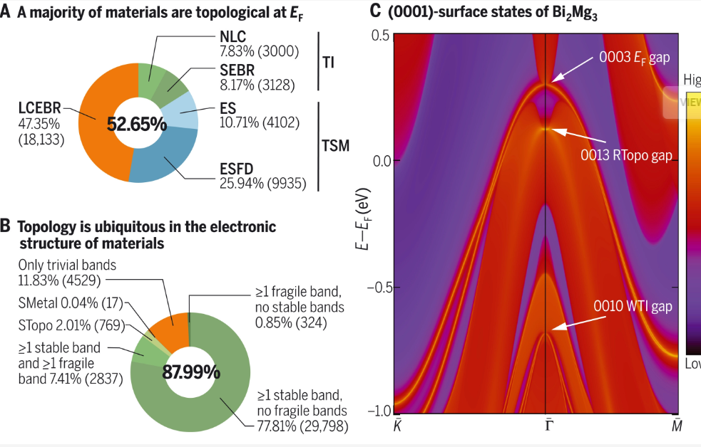

*物理学*

美国Science(《科学》)、英国Nature(《自然》)及美国Cell(《细胞》)是国际公认的三大享有最高学术声誉的科技期刊，发表在这三大期刊上的论文简称CNS论文。



[2]**Enhanced charge density wave coherence in a light-quenched, high-temperature superconductor**

**光淬高温超导体中电荷密度波的一致性增强**

**出版信息：**Science, 20 MAY 2022, VOL 376, ISSUE 6595

**作者：**S. WANDEL, F. BOSCHINI, E. H. DA SILVA NETO, L. SHEN, M. X. NA, S. ZOHARY. WANG, M. H. SEABERG , G. COSLOVICH

**第一作者单位：**Linac Coherent Light Source, SLAC National Accelerator Laboratory, Menlo Park, CA 94025, USA.

**全文链接：**<https://www.science.org/doi/10.1126/science.abd7213>

**Abstract：**Charge-density wave (CDW) order, the spatial modulation of electronic density, is known to compete with superconductivity in copper oxide superconductors. This understanding comes largely from equilibrium experiments, and the dynamics of the interplay of these orders are less explored. Wandel et al. use ultrafast laser pulses to quickly quench superconductivity in samples of the YBa2Cu3O6+x superconductor, which temporarily enhanced the CDW order. The process increased the correlation length of the CDW order, suggesting that superconductivity stabilizes CDW defects that are removed by suppressing superconductivity.

**摘要翻译：**电荷密度波（CDW）阶，即电子密度的空间调制，与氧化铜超导体中的超导性存在竞争关系。这种理解很大程度上来自于平衡实验，而对该序列相互作用的动力学研究较少。作者利用超快激光脉冲快速猝灭YBa2Cu3O6+x超导体样品中的超导性，暂时增强了CDW顺序。这一过程增加了CDW顺序的相关长度，表明超导性稳定了CDW缺陷，这些缺陷通过抑制超导性被消除。

**文中插图：**

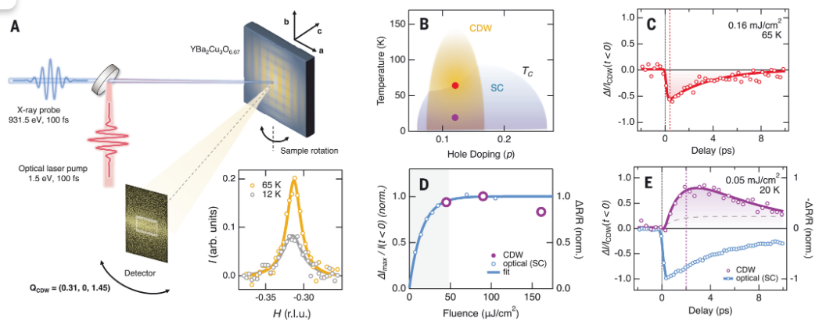



[3]Quantum gas microscopy of Kardar-Parisi-Zhang superdiffusion

**KPZ超扩散的量子气体显微镜**

**出版信息：**Science, 13 MAY 2022, VOL 376, ISSUE 6594

**作者：**DAVID WEI, ANTONIO RUBIO-ABADAL, BINGTIAN YE, FRANCISCO MACHADO, JACK KEMP, KRITSANA SRAKAEW, ET AL.

**第一作者单位：**Max-Planck-Institut für Quantenoptik, 85748 Garching, Germany. Munich Center for Quantum Science and Technology (MCQST), 80799 Munich, Germany.

**全文链接：**<https://www.science.org/doi/10.1126/science.abk2397>

**Abstract：**The Kardar-Parisi-Zhang (KPZ) universality class describes the coarse-grained behavior of a wealth of classical stochastic models. Surprisingly, KPZ universality was recently conjectured to also describe spin transport in the one-dimensional quantum Heisenberg model. We tested this conjecture by experimentally probing transport in a cold-atom quantum simulator via the relaxation of domain walls in spin chains of up to 50 spins. We found that domain-wall relaxation is indeed governed by the KPZ dynamical exponent z = 3/2 and that the occurrence of KPZ scaling requires both integrability and a nonabelian SU(2) symmetry. Finally, we leveraged the single-spin–sensitive detection enabled by the quantum gas microscope to measure an observable based on spin-transport statistics. Our results yield a clear signature of the nonlinearity that is a hallmark of KPZ universality.

**摘要翻译：**Kardar-Parisi-Zhang（KPZ）普适性类描述了大量经典随机模型的粗粒度行为。令人惊讶的是，最近人们推测KPZ普适性也可用于描述一维量子海森堡模型中的自旋输运。研究组通过多达50个自旋的自旋链畴壁弛豫，在冷原子量子模拟器中实验探测输运来验证这个猜想。他们发现，畴壁弛豫确实由KPZ动力学指数z=3/2控制，KPZ标度的出现需要可积性和非阿贝尔SU(2)对称性。最后，研究组利用量子气体显微镜实现的单自旋敏感性探测，来测量基于自旋输运统计的可观测数据。该研究结果产生了一个明确的非线性特征，这是KPZ普适性的一个标志。

**文中插图：**

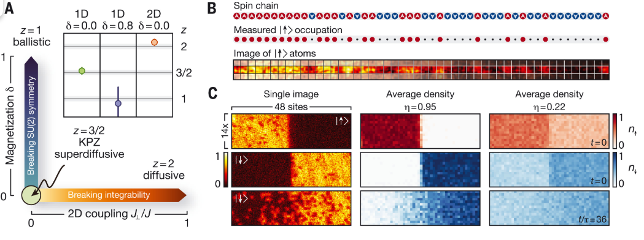



[4]**Observing emergent hydrodynamics in a long-range quantum magnet**

**在长程量子磁体中观测新兴流体动力学**

**出版信息:**Science, 13 MAY 2022, VOL 376, ISSUE 6594

**作者：**M. K. JOSHI, F. KRANZL, A. SCHUCKERT, I. LOVAS, C. MAIER, R. BLATT, ET AL.

**第一作者单位：**Institute for Quantum Optics and Quantum Information, Austrian Academy of Sciences, Technikerstraße 21a, 6020 Innsbruck, Austria.

**全文链接：**<https://www.science.org/doi/10.1126/science.abk2400>

**Abstract：**Identifying universal properties of nonequilibrium quantum states is a major challenge in modern physics. A fascinating prediction is that classical hydrodynamics emerges universally in the evolution of any interacting quantum system. We experimentally probed the quantum dynamics of 51 individually controlled ions, realizing a long-range interacting spin chain. By measuring space-time–resolved correlation functions in an infinite temperature state, we observed a whole family of hydrodynamic universality classes, ranging from normal diffusion to anomalous superdiffusion, that are described by Lévy flights. We extracted the transport coefficients of the hydrodynamic theory, reflecting the microscopic properties of the system. Our observations demonstrate the potential for engineered quantum systems to provide key insights into universal properties of nonequilibrium states of quantum matter.

**摘要翻译：**确定非平衡量子态的普适性质是现代物理学的一个重大挑战。一个有趣的预测是，经典流体力学普遍出现在任何相互作用的量子系统演化中。研究组通过实验探测了51个单独控制离子的量子动力学，实现了长程相互作用的自旋链。通过测量无限温度状态下的时空分辨关联函数，他们观测到了整个从正常扩散到反常超扩散的流体动力学普适性类家族，均由Lévy飞行描述。研究组提取了流体力学理论的输运系数，反映了系统的微观性质。该结果表明，工程量子系统有潜力为量子物质非平衡态的普适性提供关键见解。

**文中插图：**

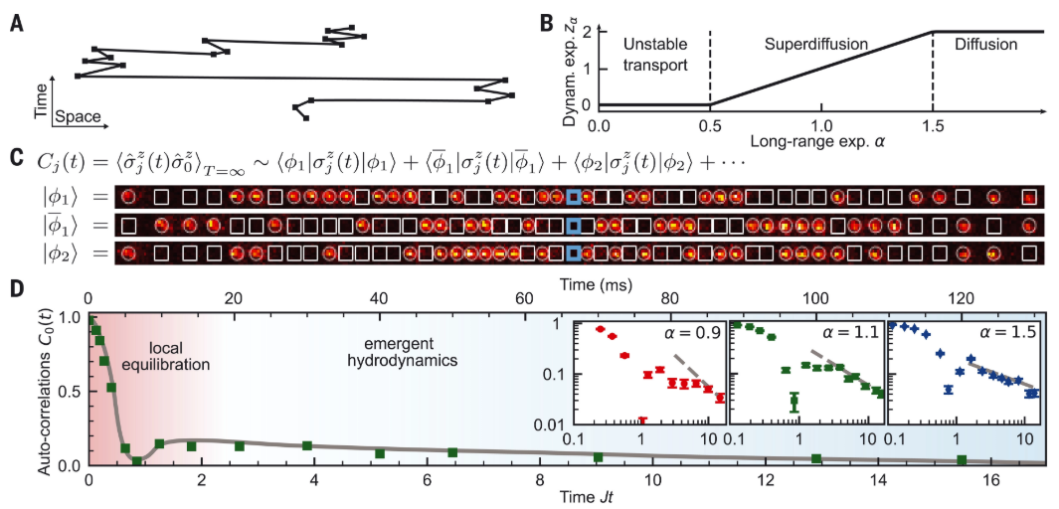



[5]**Tunable and state-preserving frequency conversion of single photons in hydrogen**

**氢中单个光子的可调谐和状态保持的频率转换**

**出版信息：**Science, 6 MAY 2022, VOLUME 376 ISSUE 6593

**作者：**R. TYUMENEV, J. HAMMER, N. Y. JOLY et al.

**第一作者单位：**Max-Planck Institute for the Science of Light, Staudtstrasse 2, 91058 Erlangen, Germany.

Present address: Interherence GmbH, Henkestrasse 91, 91052 Erlangen, Germany.

**全文链接**：<https://www.science.org/doi/10.1126/science.abn1434>

**Abstract：**In modern quantum technologies, preservation of the photon statistics of quantum optical states upon frequency conversion holds the key to the viable implementation of quantum networks, which often require interfacing of several subsystems operating in widely different spectral regions. Most current approaches offer only very small frequency shifts and limited tunability, while suffering from high insertion loss and Raman noise originating in the materials used. We introduce a route to quantum-correlation–preserving frequency conversion using hydrogen-filled antiresonant-reflecting photonic crystal fibers. Transient optical phonons generated by stimulated Raman scattering enable selective frequency up-conversion by 125 terahertz of the idler photon of an entangled pair, with efficiencies up to 70%. This threshold-less molecular modulation process preserves quantum correlations, making it ideal for applications in quantum information.

**摘要翻译：**爱因斯坦的广义相对论指出，时钟在不同的引力势下，相对于实验室坐标的速度是不同的——这一效应被称为引力红移。作为空间和时间的基本探测器，原子钟长期以来被用于在30厘米到数千公里的距离尺度上检验这一预测。一旦时钟对弯曲时空中振荡的量子物体的有限波函数变得敏感，将使广义相对论和量子力学的结合研究成为可能。作者在一个毫米尺度的超冷锶样品中测量了与引力红移一致的线性频率梯度。通过将分数频率测量的不确定度提高10倍以上，达到7.6 × 10−21，研究结果得以实现。这预示着一种新的时钟操作方式，需要对引力扰动进行样品内校正。

**文中插图：**

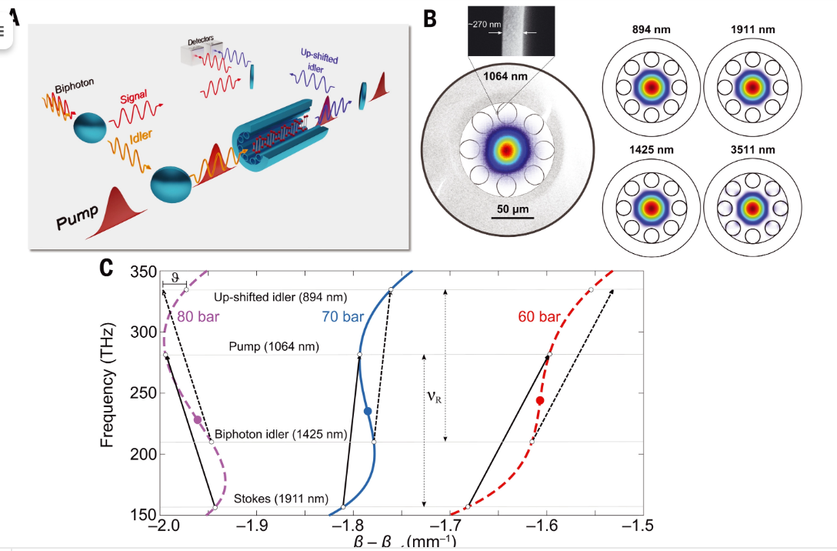



*物理学*

[1]**Free-electron lasing with compact beam-driven plasma wakefield accelerator**

**紧凑型束流驱动等离子体尾场加速器的自由电子激光**

**出版信息：**Nature,26 May 2022, VOL 605, ISSUE 7911

**作者：**R. Pompili, D. Alesini, M. P. Anania, S. Arjmand, M. Behtouei, M. Bellaveglia, et al.

**第一作者单位：**Laboratori Nazionali di Frascati, Frascati, Italy

**全文链接：**<https://www.nature.com/articles/s41586-022-04579-3>

**Abstract：**The possibility to accelerate electron beams to ultra-relativistic velocities over short distances by using plasma-based technology holds the potential for a revolution in the field of particle accelerators. The compact nature of plasma-based accelerators would allow the realization of table-top machines capable of driving a free-electron laser (FEL), a formidable tool to investigate matter at the sub-atomic level by generating coherent light pulses with sub-ångström wavelengths and sub-femtosecond durations. So far, however, the high-energy electron beams required to operate FELs had to be obtained through the use of conventional large-size radio-frequency (RF) accelerators, bound to a sizeable footprint as a result of their limited accelerating fields. Here we report the experimental evidence of FEL lasing by a compact (3-cm) particle-beam-driven plasma accelerator. The accelerated beams are completely characterized in the six-dimensional phase space and have high quality, comparable with state-of-the-art accelerators. This allowed the observation of narrow-band amplified radiation in the infrared range with typical exponential growth of its intensity over six consecutive undulators. This proof-of-principle experiment represents a fundamental milestone in the use of plasma-based accelerators, contributing to the development of next-generation compact facilities for user-oriented applications.

**摘要翻译：**等离子体技术可在短距离内将电子束加速到超相对论速度，这有望为粒子加速器领域带来一场革命。基于等离子体加速器的紧凑特性有望实现能够驱动自由电子激光器（FEL）的台式机器，这是一种强大的工具，通过产生亚埃米波长和亚飞秒持续时间的相干光脉冲，来研究亚原子水平的物质。但迄今为止，操作FEL所需的高能电子束必须通过使用传统的大型射频（RF）加速器来获得，由于加速场有限，其占地面积相当大。研究组报道了一个紧凑型（3cm）粒子束驱动等离子体加速器产生FEL的实验证据。加速光束在六维相空间中可完全表征，质量高，可与最先进的加速器媲美。这使得人们能够在红外范围内观察到窄带放大辐射，其强度在六个连续波荡器上呈典型的指数增长。该原理验证实验代表了等离子体加速器使用的一个里程碑，有助于开发面向用户的下一代紧凑型设备。

**文中插图：**

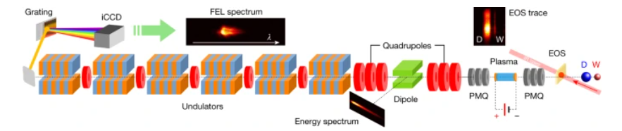

**5月Nature 论文**



[2]Microcomb-driven silicon photonic systems

**微腔光梳驱动的硅光子系统**

**出版信息：**Nature, 19 May 2022, Volume 605 Issue 7910

**作者：**Haowen Shu, Lin Chang, Yuansheng Tao, Bitao Shen, Weiqiang Xie, Ming Jin, Andrew Netherton, Zihan Tao, Xuguang Zhang, Ruixuan Chen, Bowen Bai, Jun Qin, Shaohua Yu, Xingjun Wang & John E. Bowers

**第一作者单位：**State Key Laboratory of Advanced Optical Communications System and Networks, School of Electronics, Peking University, Beijing, China

**全文链接：<https://www.nature.com/articles/s41586-022-04579-3>**

**Abstract：**Here we combine these two technologies by using a power-efficient and operationally simple aluminium-gallium-arsenide-on-insulator microcomb source to drive complementary metal–oxide–semiconductor SiPh engines. We present two important chip-scale photonic systems for optical data transmission and microwave photonics, respectively. A microcomb-based integrated photonic data link is demonstrated, based on a pulse-amplitude four-level modulation scheme with a two-terabit-per-second aggregate rate, and a highly reconfigurable microwave photonic filter with a high level of integration is constructed using a time-stretch approach. Such synergy of a microcomb and SiPh integrated components is an essential step towards the next generation of fully integrated photonic systems.

**摘要翻译：**在此，我们使用一种节能且操作简单的铝-镓-砷-绝缘体微梳源将两种技术结合起来，来驱动互补金属氧化物-半导体硅基光电子片。我们分别展示了用于光数据传输和微波光子学的两种重要的芯片级光子系统。我们展示了一种基于微腔光梳的集成光子数据链路，基于脉冲振幅四电平调制方案，以每秒2太比特的聚合速率，并使用时间拉伸方法构造了具有高集成水平的高可重构微波光子滤波器。这种微腔光梳和硅基光电子片集成组件的协同作用是迈向下一代完全集成光子系统的重要一步。

**文中插图：**

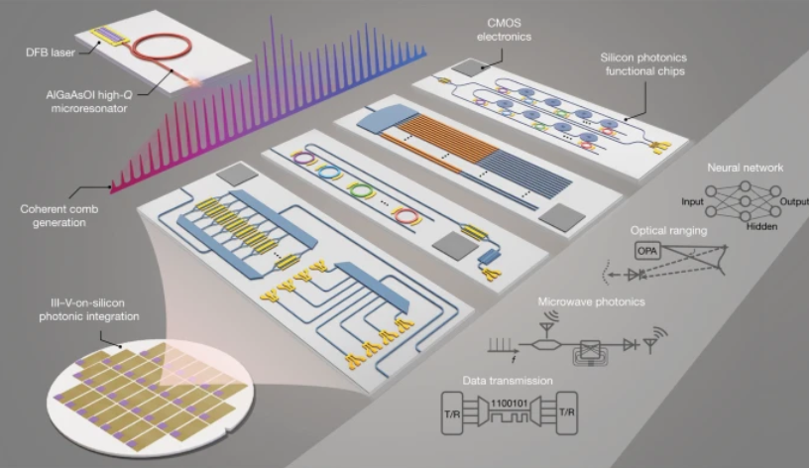



**[3]Observation of a molecular bond between ions and Rydberg atoms**

**离子和里德堡原子之间的分子键**

**出版信息：Nature, 19 May 2022, Volume 605 Issue 7910**

**作者：Nicolas Zuber, Viraatt S. V. Anasuri, Moritz Berngruber, Yi-Quan Zou, Florian Meinert, Robert L?w & Tilman Pfau**

**第一作者单位：5. Physikalisches Institut and Center for Integrated Quantum Science and Technology, Universität Stuttgart, Stuttgart, Germany**

**全文链接：**<https://www.nature.com/articles/s41586-022-04577-5>

**Abstract：Here we observe a new type of molecular ion based on the interaction between the ionic charge and a flipping-induced dipole of a Rydberg atom with a bond length of several micrometres. We measure the vibrational spectrum and spatially resolve the bond length and the angular alignment of the molecule using a high-resolution ion microscope. As a consequence of the large bond length, the molecular dynamics is extremely slow. These results pave the way for future studies of spatio-temporal effects in molecular dynamics (for example, beyond Born–Oppenheimer physics).**

**摘要翻译：在此，基于离子电荷与键长为几微米的里德堡原子的翻转诱导偶极子之间的相互作用，我们观察到一种新型的分子离子。我们测量振动谱，并利用高分辨率离子显微镜在空间上解析分子的键长和角对齐。由于键长较大，分子动力学非常缓慢。这些结果为分子动力学时空效应的未来研究铺平了道路。**

**文中插图：**

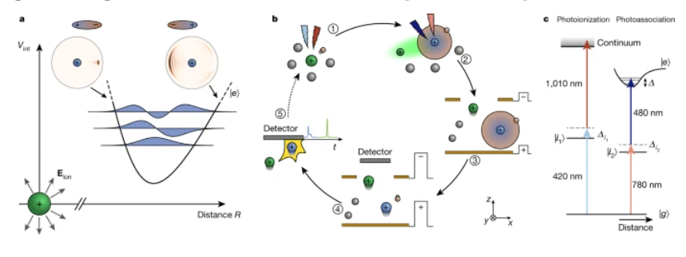

*材料科学*





[4]**Direct observation of the dead-cone effect in quantum chromodynamics**

**量子色动力学中的死角效应**

**出版信息：**Nature, 19 May 2022, Volume 605 Issue 7910

**作者：**ALICE Collaboration

**全文链接：**<https://www.nature.com/articles/s41586-022-04572-w>

**Abstract：**In particle collider experiments, elementary particle interactions with large momentum transfer produce quarks and gluons (known as partons) whose evolution is governed by the strong force, as described by the theory of quantum chromodynamics (QCD). Previously, a direct observation of the dead-cone effect in QCD had not been possible, owing to the challenge of reconstructing the cascading quarks and gluons from the experimentally accessible hadrons. We report the direct observation of the QCD dead cone by using new iterative declustering techniques to reconstruct the parton shower of charm quarks. This result confirms a fundamental feature of QCD. Furthermore, the measurement of a dead-cone angle constitutes a direct experimental observation of the non-zero mass of the charm quark, which is a fundamental constant in the standard model of particle physics.

**摘要翻译：**在粒子对撞机实验中，具有大动量转移的基本粒子相互作用产生夸克和胶子（称为部分子）。正如量子色动力学（QCD）理论所描述的那样，它们的演化受强作用力控制。以前，由于从实验可及的强子中重建级联夸克和胶子的挑战，直接观察QCD中的死角效应是不可能的。

我们报告用新的迭代聚类技术重建粲夸克的部分子簇的QCD死角的直接观测。这一结果证实了QCD的一个基本特征。此外，死角角度的测量构成了对粒子物理标准模型中的基本常数——粲夸克非零质量的直接实验观测。

**文中插图：**

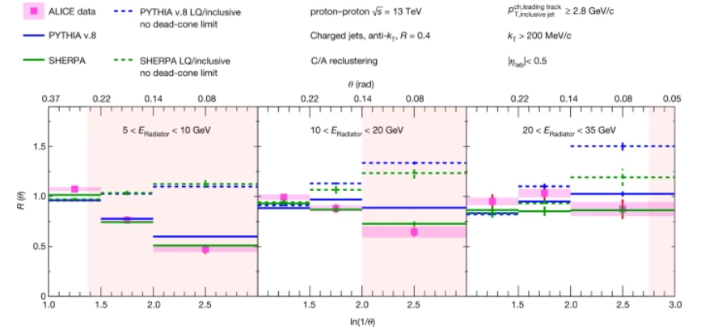





[5]**Polariton Bose–Einstein condensate from a bound state in the continuum**

**连续谱束缚态中的极化激元玻色-爱因斯坦凝聚物**

**出版信息：**Nature, 19 May 2022, Volume 605 Issue 7910

**作者：**V. Ardizzone, F. Riminucci, S. Zanotti, A. Gianfrate, M. Efthymiou-Tsironi, D. G. Suàrez-Forero, F. Todisco, M. De Giorgi, D. Trypogeorgos, G. Gigli, K. Baldwin, L. Pfeiffer, D. Ballarini, H. S. Nguyen, D. Gerace & D. Sanvitto

**第一作者单位：**CNR Nanotec, Institute of Nanotechnology, Lecce, Italy

Dipartimento di Matematica e Fisica ‘Ennio De Giorgi’, Università del Salento, Lecce, Italy

**全文链接：**<https://www.nature.com/articles/s41586-022-04583-7>

**Abstract：**Here we show non-equilibrium Bose–Einstein condensation of polaritons—hybrid light–matter excitations—occurring in a BIC thanks to its peculiar non-radiative nature, which favours polariton accumulation. The combination of the ultralong BIC lifetime and the tight confinement of the waveguide geometry enables the achievement of an extremely low threshold density for condensation, which is reached not in the dispersion minimum but at a saddle point in reciprocal space. By bridging bosonic condensation and symmetry-protected radiation eigenmodes, we reveal ways of imparting topological properties onto macroscopic quantum states with unexplored dispersion features. Such an observation may open a route towards energy-efficient polariton condensation in cost-effective integrated devices, ultimately suited for the development of hybrid light–matter optical circuits.

**摘要翻译：**在此，我们展示了在连续谱束缚态（BIC）中发生的非平衡玻色-爱因斯坦凝聚-混合光物质激发，这是由于其特殊的非辐射性质，有利于极化子的积累。超长BIC寿命和波导几何结构的紧密约束相结合，能够实现极低的冷凝阈值密度，这不是在色散最小值中达到的，而是在倒数空间中的鞍点达到的。通过连接玻色子凝聚和对称保护辐射本征模，我们揭示了将拓扑性质传递到具有未探索色散特性的宏观量子态的方法。这一发现可能为低成本集成器件的节能极化子凝聚开辟道路，最终适合于开发混合光物质光学电路。

**文中插图：**

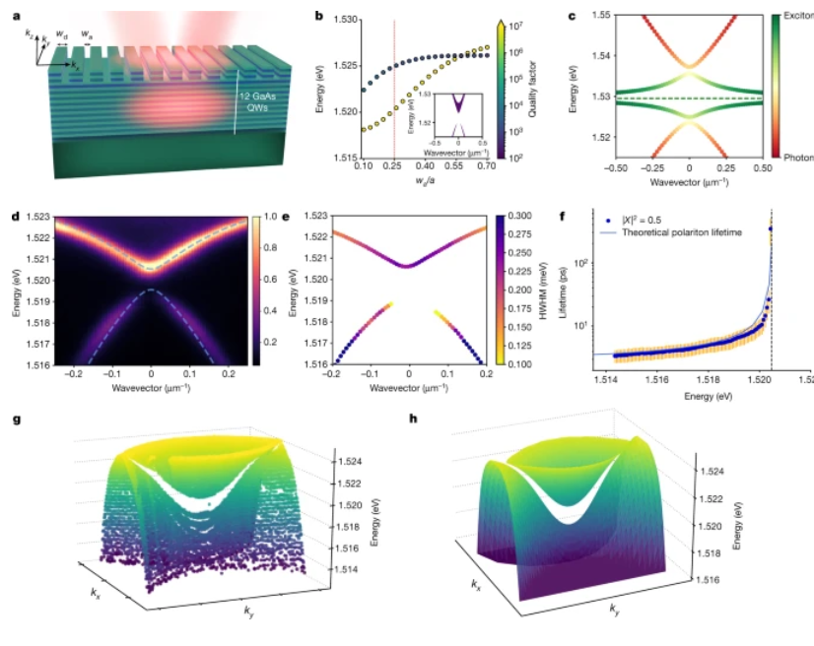





[6]Suppression of black-hole growth by strong outflows at redshifts 5.8–6.6

**红移5.8-6.6时强劲的流出抑制黑洞增长**

**出版信息：**Nature, 12 May 2022, Volume 605 Issue 7909

**作者：**M. Bischetti, C. Feruglio, F. Fiore Show authors

**第一作者单位：**Department of Physics, Massachusetts Institute of Technology, Cambridge, MA, USA.

**全文链接：**<https://www.nature.com/articles/s41586-022-04608-1>

**Abstract：**Bright quasars, powered by accretion onto billion-solar-mass black holes, already existed at the epoch of reionization, when the Universe was 0.5–1 billion years old1. How these black holes formed in such a short time is the subject of debate, particularly as they lie above the correlation between black-hole mass and galaxy dynamical mass in the local Universe. What slowed down black-hole growth, leading towards the symbiotic growth observed in the local Universe, and when this process started, has hitherto not been known, although black-hole feedback is a likely driver. Here we report optical and near-infrared observations of a sample of quasars at redshifts 5.8 ≲ z ≲ 6.6. About half of the quasar spectra reveal broad, blueshifted absorption line troughs, tracing black-hole-driven winds with extreme outflow velocities, up to 17% of the speed of light. The fraction of quasars with such outflow winds at z ≳ 5.8 is ≈2.4 times higher than at z ≈ 2–4. We infer that outflows at z ≳ 5.8 inject large amounts of energy into the interstellar medium and suppress nuclear gas accretion, slowing down black-hole growth. The outflow phase may then mark the beginning of substantial black-hole feedback. The red optical colours of outflow quasars at z ≳ 5.8 indeed suggest that these systems are dusty and may be caught during an initial quenching phase of obscured accretion.

**摘要翻译：**明亮的类星体，被十亿个太阳质量的黑洞吸积而成，在宇宙5亿~ 10亿年的再电离时期就已经存在了。这些黑洞是如何在如此短的时间内形成的，是一个有争议的话题，尤其是当它们位于黑洞质量与本宇宙中星系动力学质量之间的相关性上时。是什么减缓了黑洞的增长？导致在宇宙中观察到的共生增长？这个过程是何时开始的？这些答案迄今尚不知晓，尽管黑洞反馈可能是一个驱动因素。作者报告在红移5.8≤z≤6.6的类星体样本的光学和近红外观测。通过追踪由黑洞驱动的风的极端外流速度（高达光速的17%），类星体光谱的约一半显示出宽的蓝移吸收线槽。在z≥5.8处存在这种外流风的类星体比例比z≈2-4处高约2.4倍。他们推断z≥5.8处的流出物向星际介质注入了大量的能量，抑制了核气体的吸积，减缓了黑洞的增长。流出阶段可能标志着大量黑洞反馈的开始。在z≥5.8流出的类星体的红色光学颜色确实表明，这些系统满是尘埃，可能会在模糊吸积的初始熄灭阶段被捕捉到。

**文中插图：**

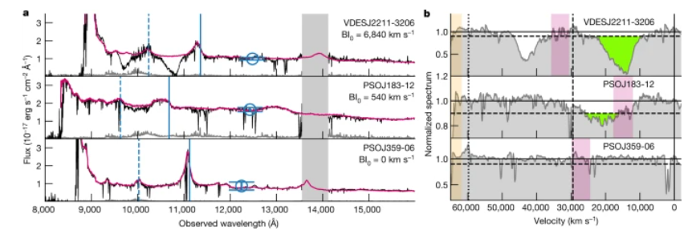



[7]**X-ray detection of a nova in the fireball phase**

**用X射线探测到火球阶段的新星**

**出版信息：**Nature, 12 May 2022, Volume 605 Issue 7909

**作者：**Ole König, Jörn Wilms, Riccardo Arcodia, Thomas Dauser, Konrad Dennerl, Victor Doroshenko, Frank Haberl, Steven Hämmerich, Christian Kirsch, Ingo Kreykenbohm, Maximilian Lorenz, Adam Malyali, Andrea Merloni, Arne Rau, Thomas Rauch, Gloria Sala, Axel Schwope, Valery Suleimanov, Philipp Weber & Klaus Werner

**第一作者单位：**Dr. Karl Remeis-Observatory and Erlangen Centre for Astroparticle Physics, Friedrich-Alexander-Universität Erlangen-Nürnberg, Bamberg, Germany

**全文链接：**<https://www.nature.com/articles/s41586-022-04635-y>

**Abstract：**Novae are caused by runaway thermonuclear burning in the hydrogen-rich envelopes of accreting white dwarfs, which leads to a rapid expansion of the envelope and the ejection of most of its mass. Theory has predicted the existence of a ‘fireball’ phase following directly on from the runaway fusion, which should be observable as a short, bright and soft X-ray flash before the nova becomes visible in the optical. Here we report observations of a bright and soft X-ray flash associated with the classical Galactic nova YZ Reticuli 11 h before its 9 mag optical brightening. No X-ray source was detected 4 h before and after the event, constraining the duration of the flash to shorter than 8 h. In agreement with theoretical predictions, the source’s spectral shape is consistent with a black-body of 3.27+0.11−0.33 × 105 K (28.2+0.9−2.8 eV), or a white dwarf atmosphere, radiating at the Eddington luminosity, with a photosphere that is only slightly larger than a typical white dwarf.

**摘要翻译：**新星的产生是由于富含氢的吸积白矮星的包膜发生失控的热核燃烧，这导致了包膜的快速膨胀和大部分质量的喷射。理论预测，在逃逸的核聚变之后，存在一个“火球”阶段，在新星变为可见光之前，应该可以观测到一个短暂、明亮的软X射线闪光。作者报告了在经典银河新星YZ Reticuli的9级磁光学变亮前11小时的一个明亮的软X射线闪光的观测结果。事件发生前4小时和发生后4小时内均未检测到X射线源，这限制了闪光持续时间小于8小时。与理论预测一致的是，该源的光谱形状与一个3.27+0.11 - 0.33 × 105 K的黑色天体一致，或一个以爱丁顿光度辐射的白矮星大气层一致，其光球只比典型的白矮星略大。

**文中插图：**

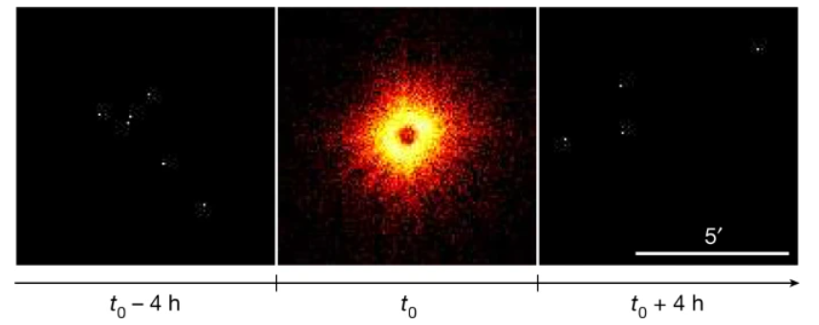



[8]**Light-field control of real and virtual charge carriers**

**实和虚载流子的光场控制**

**出版信息：Nature, 12 May 2022, Volume 605 Issue 7909**

**作者：**Tobias Boolakee, Christian Heide, Antonio Garzón-Ramírez, Heiko B. Weber, Ignacio Franco & Peter Hommelhoff

**第一作者单位：**Department of Physics, Friedrich-Alexander-Universität Erlangen-Nürnberg (FAU), Erlangen, Germany

**全文链接：**<https://www.nature.com/articles/s41586-022-04565-9>

**Abstract：**Light-driven electronic excitation is a cornerstone for energy and information transfer. In the interaction of intense and ultrafast light fields with solids, electrons may be excited irreversibly, or transiently during illumination only. As the transient electron population cannot be observed after the light pulse is gone, it is referred to as virtual, whereas the population that remains excited is called real. Virtual charge carriers have recently been associated with high-harmonic generation and transient absorption, but photocurrent generation may stem from real as well as virtual charge carriers. However, a link between the generation of the carrier types and their importance for observables of technological relevance is missing. Here we show that real and virtual charge carriers can be excited and disentangled in the optical generation of currents in a gold–graphene–gold heterostructure using few-cycle laser pulses. Depending on the waveform used for photoexcitation, real carriers receive net momentum and propagate to the gold electrodes, whereas virtual carriers generate a polarization response read out at the gold–graphene interfaces. On the basis of these insights, we further demonstrate a proof of concept of a logic gate for future lightwave electronics. Our results offer a direct means to monitor and excite real and virtual charge carriers. Individual control over each type of carrier will markedly increase the integrated-circuit design space and bring petahertz signal processing closer to reality.

**摘要翻译：**光驱动电子激发是能量和信息传递的基石。在强超快光场与固体的相互作用中，电子被不可逆地或仅在照明时被瞬态地激发。由于在光脉冲消失后无法观测到瞬态电子布居，因此称为虚电子布居，而仍然处于激发态的电子布居称为实电子布居。虚载流子最近被认为与高谐波产生和瞬态吸收有关，但光电流的产生可能来自真实和虚载流子。然而，载体类型的生成和它们对技术相关性的重要性之间的联系缺失。作者证明了在金-石墨烯-金异质结构中，用低周期激光脉冲可以激发和解缠实和虚载流子产生电流。根据用于光激发的波形，真实载流子接收净动量并传播到金电极，而虚拟载流子产生在金-石墨烯界面读出的极化响应。在此基础上，他们进一步论证了未来光波电子学中逻辑门的概念证明。该结果提供了一种直接的方法来监测和激发实和虚载流子。单独控制每种类型的载波将显著增加集成电路的设计空间，使千赫信号处理更接近现实。

**文中插图：**

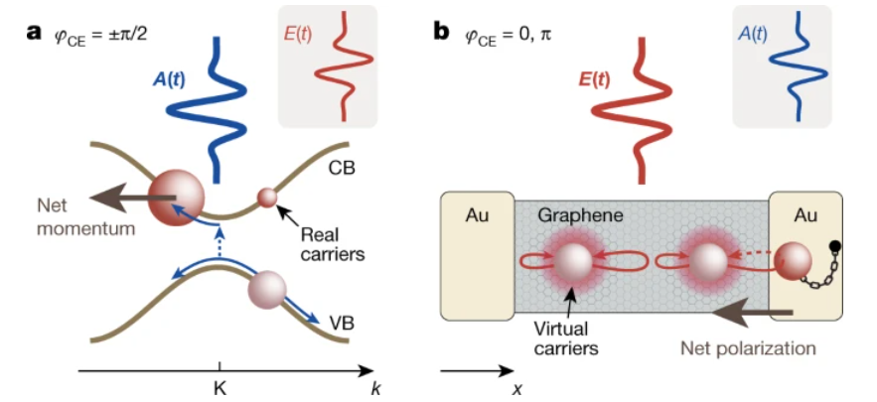





[9]**Single electrons on solid neon as a solid-state qubit platform**

**氖冰上单电子构建固态量子比特平台**

**出版信息：**Nature,  5 May 2022, VOL 605, ISSUE 7908

**作者：**Xianjing Zhou, Gerwin Koolstra, Xufeng Zhang, Ge Yang, Xu Han, Brennan Dizdar, et al.

**第一作者单位：**Center for Nanoscale Materials, Argonne National Laboratory, Lemont, IL, USA

**全文链接：**<https://www.nature.com/articles/s41586-022-04539-x>

**Abstract：**Progress towards the realization of quantum computers requires persistent advances in their constituent building blocks—qubits. Novel qubit platforms that simultaneously embody long coherence, fast operation and large scalability offer compelling advantages in the construction of quantum computers and many other quantum information systems. Electrons, ubiquitous elementary particles of non-zero charge, spin and mass, have commonly been perceived as paradigmatic local quantum information carriers. Despite superior controllability and configurability, their practical performance as qubits through either motional or spin states depends critically on their material environment. Here we report our experimental realization of a qubit platform based on isolated single electrons trapped on an ultraclean solid neon surface in vacuum. By integrating an electron trap in a circuit quantum electrodynamics architecture, we achieve strong coupling between the motional states of a single electron and a single microwave photon in an on-chip superconducting resonator. Qubit gate operations and dispersive readout are implemented to measure the energy relaxation time  T1 of 15 μs and phase coherence time  T2 over 200 ns. These results indicate that the electron-on-solid-neon qubit already performs near the state of the art for a charge qubit.

**摘要翻译：**量子计算机的实现需要其组成构建块（量子比特）的持续进步。同时体现长相干、快速运算和较大可扩展性的新型量子比特平台在量子计算机和许多其他量子信息系统的构建中具有引人注目的优势。电子是普遍存在的具有非零电荷、自旋和质量的基本粒子，通常被认为是典型的局域量子信息载体。尽管具有优越的可控性和可配置性，但它们作为量子比特在运动或自旋状态下的实际性能关键取决于它们的物质环境。研究组报道他们通过实验实现了一个量子比特平台，基于真空中孤立单电子被捕获在超洁净氖冰表面。通过在电路量子电动力学结构中集成电子阱，研究组在芯片上的超导谐振器中实现了单个电子和单个微波光子运动态之间的强耦合。通过量子比特门运算和色散读出，研究组测出能量弛豫时间T1为15 μs，相位相干时间T2超过200 ns。这些结果表明，电子-氖冰量子比特的性能已接近电荷量子比特的最新水平。

**文中插图：**

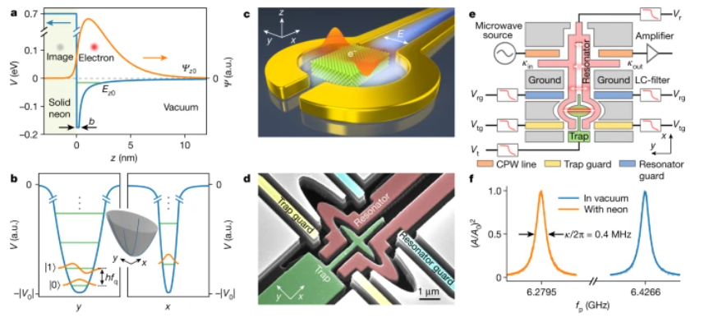



[10]**Uniform nucleation and epitaxy of bilayer molybdenum disulfide on sapphire**

**蓝宝石上双层二硫化钼的均匀形核和外延**

**出版信息：**Nature,  5 May 2022, VOL 605, ISSUE 7908

**作者：**Lei Liu, Taotao Li, Liang Ma, Weisheng Li, Si Gao, Wenjie Sun, et al.

**第一作者单位：**National Laboratory of Solid State Microstructures, School of Electronic Science and Engineering and Collaborative Innovation Center of Advanced Microstructures, Nanjing University, Nanjing, China

**全文链接：**<https://www.nature.com/articles/s41586-022-04523-5>

**Abstract：**Two-dimensional transition-metal dichalcogenides (TMDs) are of interest for beyond-silicon electronics. It has been suggested that bilayer TMDs, which combine good electrostatic control, smaller bandgap and higher mobility than monolayers, could potentially provide improvements in the energy-delay product of transistors. However, despite advances in the growth of monolayer TMDs, the controlled epitaxial growth of multilayers remains a challenge. Here we report the uniform nucleation (>99%) of bilayer molybdenum disulfide (MoS2) on c-plane sapphire. In particular, we engineer the atomic terrace height on c-plane sapphire to enable an edge-nucleation mechanism and the coalescence of MoS2domains into continuous, centimetre-scale films. Fabricated field-effect transistor (FET) devices based on bilayer MoS2 channels show substantial improvements in mobility (up to 122.6 cm2 V−1 s−1) and variation compared with FETs based on monolayer films. Furthermore, short-channel FETs exhibit an on-state current of 1.27mA μm−1, which exceeds the 2028 roadmap target for high-performance FETs.

**摘要翻译：**二维过渡金属二卤化物（TMD）是超硅电子领域的研究热点。有研究认为，与单层TMD相比，双层TMD具有更好的静电控制、更小的带隙和更高的迁移率，有望改善晶体管的能量延迟产物。虽然单层TMD的生长取得了进展，但多层TMD的可控外延生长仍是一个挑战。研究组报道了双层二硫化钼（MoS2）在c-面蓝宝石上的均匀形核（>99%）。他们设计了c-面蓝宝石上的原子平台高度，以实现边缘形核机制，并将MoS2畴合并成连续的厘米级薄膜。基于双层MoS2通道制造的场效应晶体管（FET）器件在迁移率（高达122.6 cm2 V−1 s−1）和变异性方面，与基于单层膜的FET器件相比有显著改善。此外，短通道FET的通态电流为1.27 mA μm−1，超越了高性能FET的2028路线图目标。

**文中插图：**

