User Manual for the Self-Service System of Literature Retrieval Reports

Content

**1. System Flowchart 2**

**2. Authentication and Login 2**

**1) Log in to the system 2**

**2) Log in to the system 2**

**3) Read Terms and Conditions 3**

**4) Fill in the Form 3**

**5) Paper and Report Processing 4**

**a) Claimed results: 4**

**b) Add Claimed results : 4**

**6) Report Retrieval: 5**

**7) Notes 6**

# System Flowchart

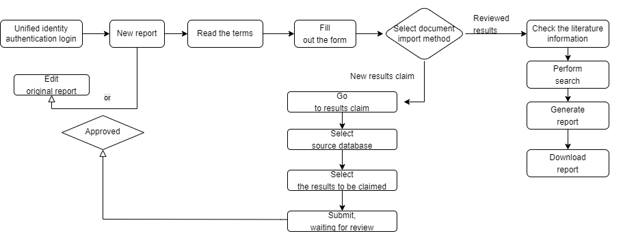

**Note:** First-time users should select "Add New Claimed results" under "Import Method".

The system only supports retrieval reports for papers affiliated with Southeast University.

# Authentication and Login

1. **Log in to the system**

* Visit: <http://10.9.0.38/kycgfwptweb/login?platform_redirect_key=cscy>
* Select "unified identity authentication login".

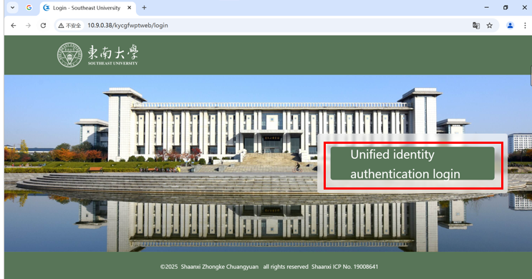

1. **Log in to the system**

* After successful login, click "create a new report" to enter the module.

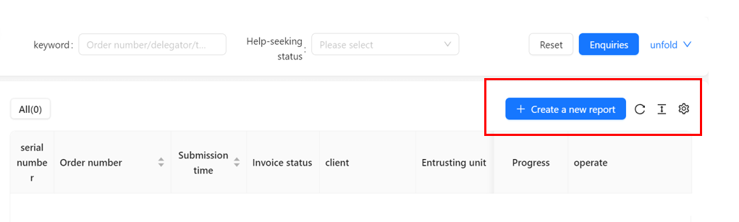

1. **Read Terms and Conditions**

* Carefully read and confirm understanding of the service terms before proceeding.

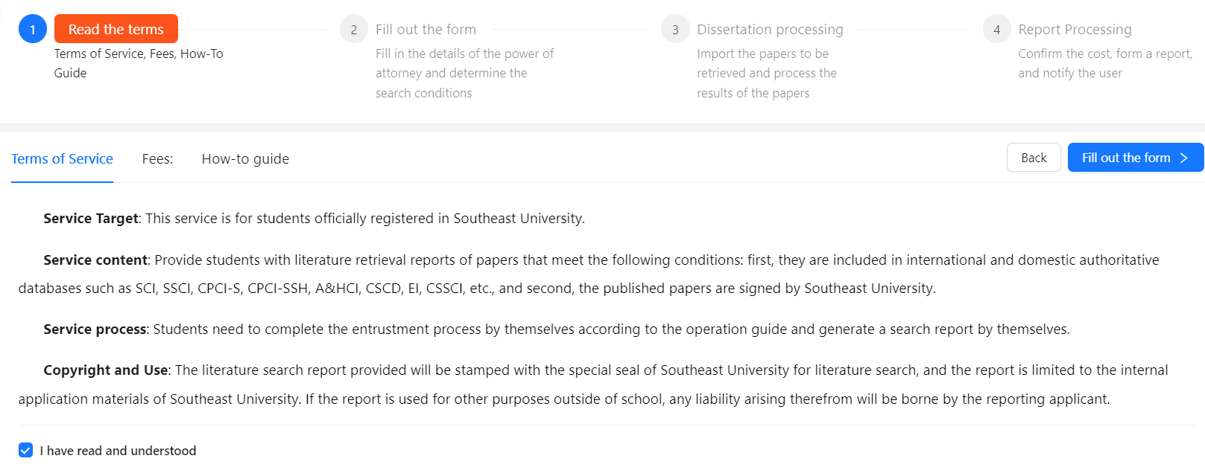

1. **Fill in the Form**

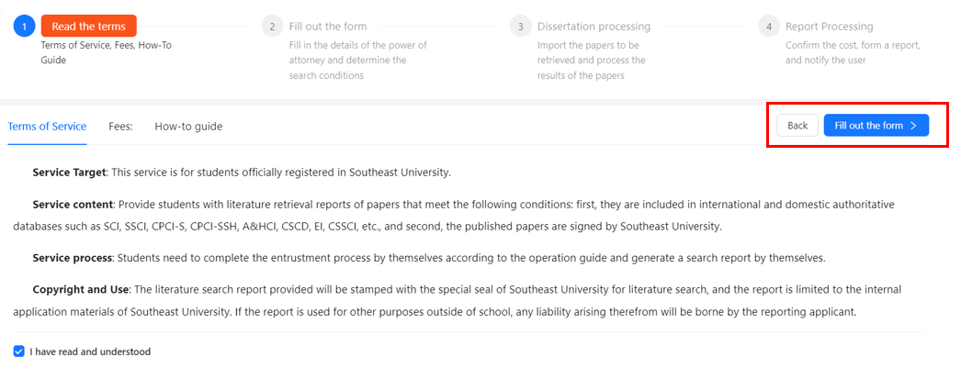

* Complete required personal information (fields marked with *).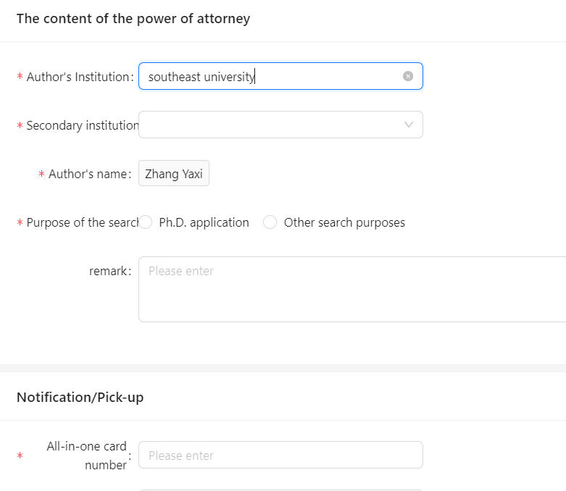
* Choose one target database per report. 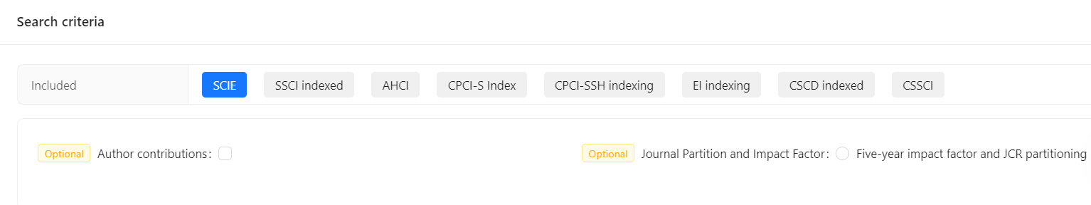
* To retrieve from multiple databases, submit and create a new report after each completion.

1. **Paper and Report Processing**
2. **Claimed results:**

* Click "Claimed results " to view the list of claimed papers.
* Select needed papers and click "lead".

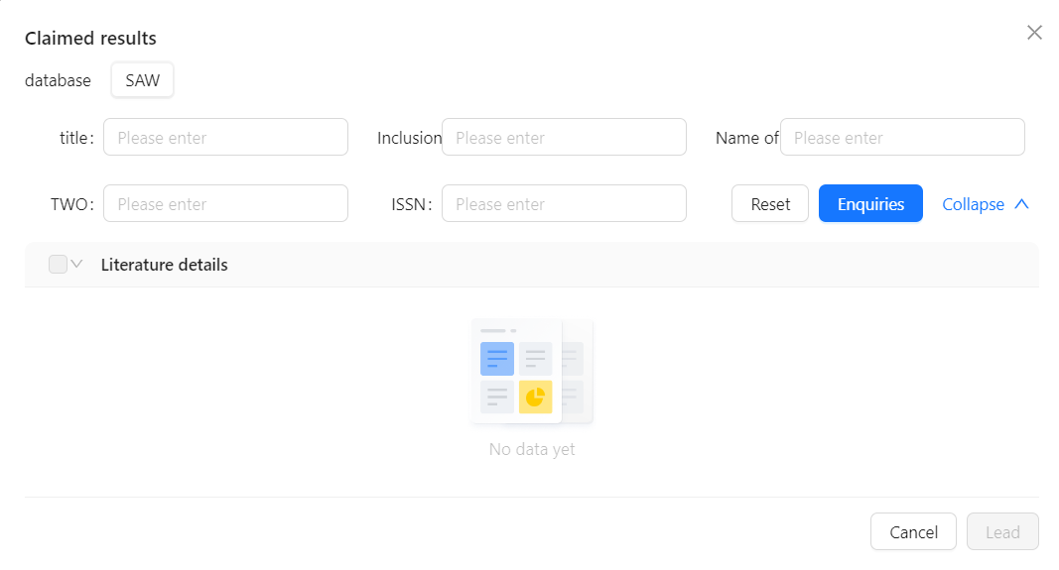

* If all are found, proceed to retrieval.
* If none found or message says "No Data", move to 6.2.

1. **Add Claimed results :**

* Click "Add Claimed results" to enter the Data Science Platform.
* Choose author and confirm to claim.

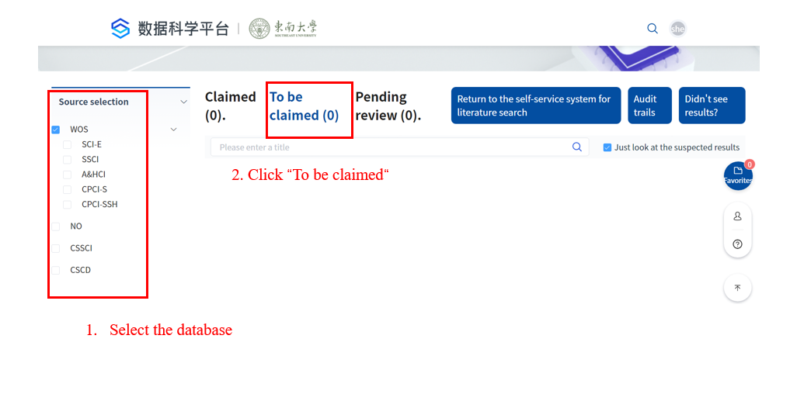

* Please note to enter your English name when claiming.

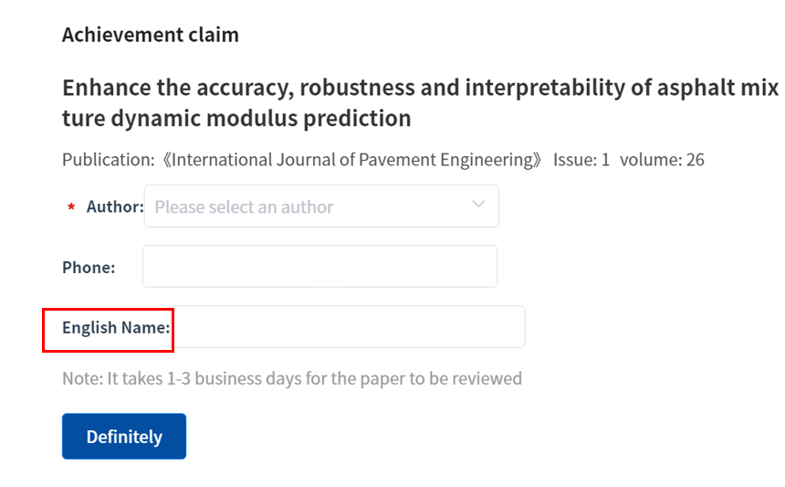

* Await librarian approval.
* 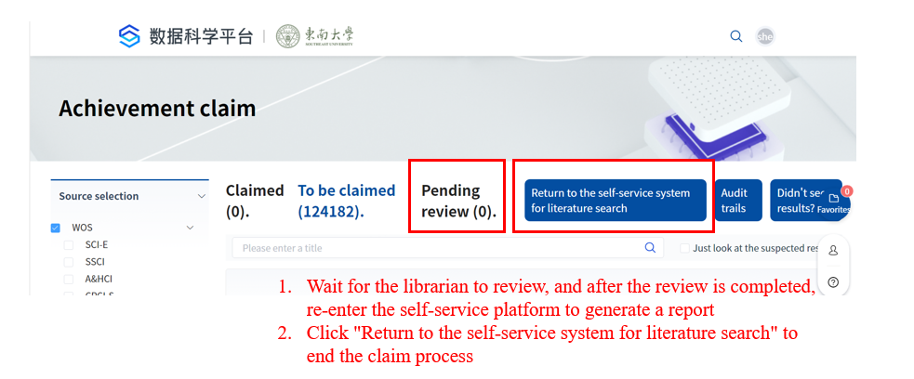
* Check your claiming records in the “Audit trials”.

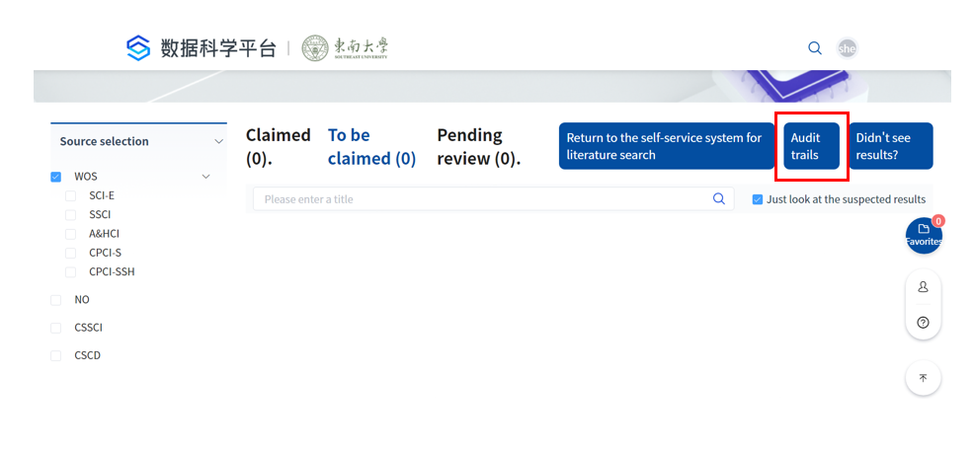

* Once approved, continue editing the current report or start a new one.

If not listed, uncheck "Only show suspected achievements" and search by title.

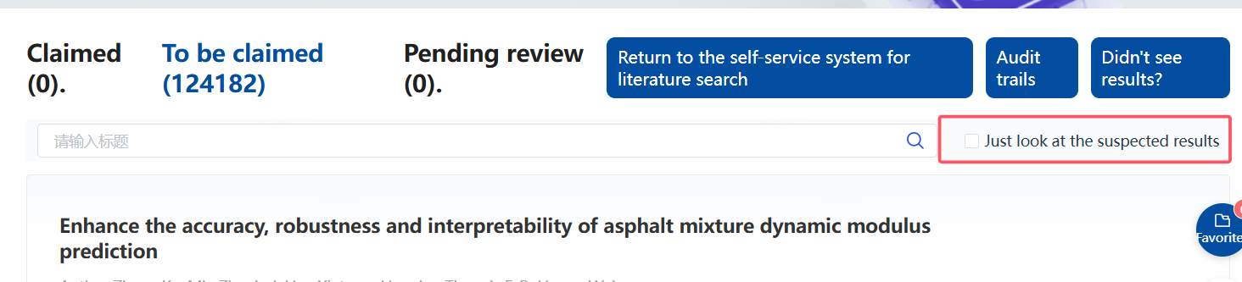

Still not found? Click "Didn’t see results" and submit feedback. The database updates weekly. Check the feedback status under your feedback records.

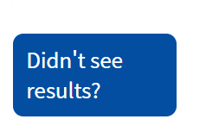

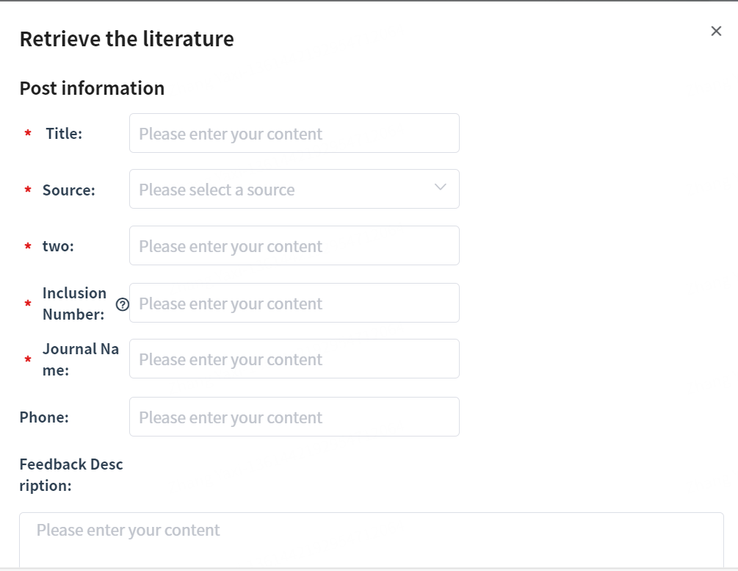

1. **Report Retrieval:**

* Click "start your search ". The system will automatically generate the report.

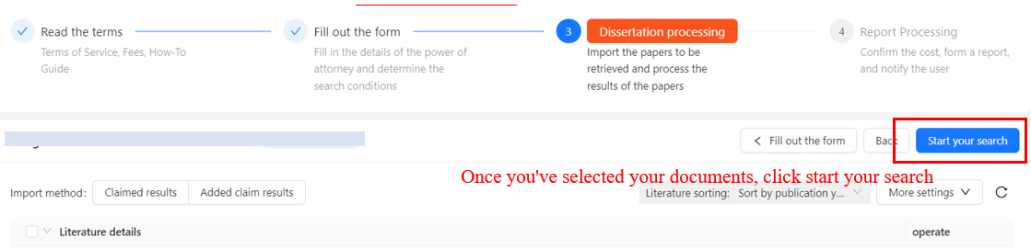

* Wait for the progress bar to complete.
* Refresh the page and click "Download" to obtain the report.

1. **Notes**

* The system only generates reports for papers with Southeast University as the affiliated institution.
* For further assistance, please contact: 52090336.